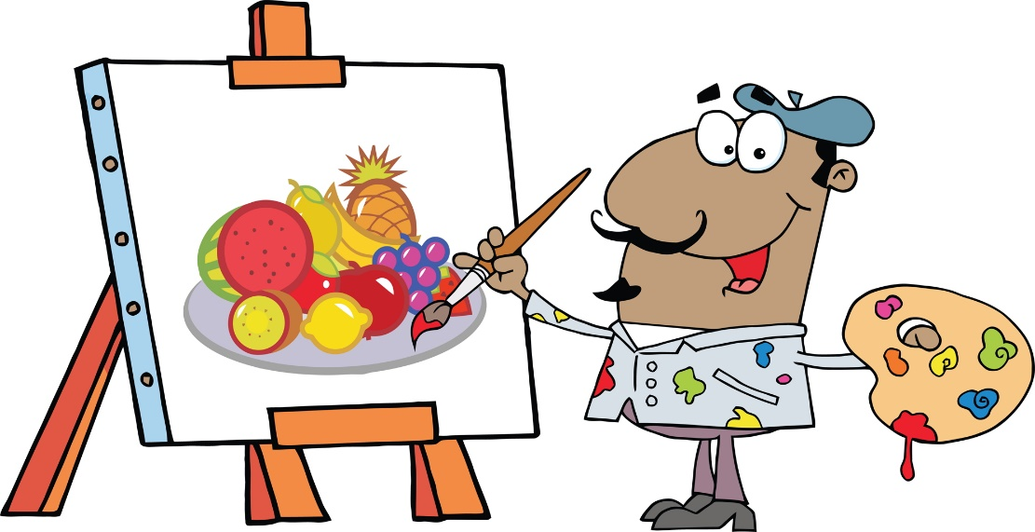

Free Sunday Painters!

**The public** is invited to come and paint for **FREE** with an A3L Instructor **EVERY 2ND SUNDAY** from 2 to 4. Learn a variety of techniques and take home a finished painting! All Supplies are furnished for your 1st two times, then class is free but bring your own supplies!

**Register by the Weds** before class so volunteer instructor prepare.

Come join the fun!!